Minimising Restraint – Residential Aged Care Facilities
The ‘Minimising Restraint – Residential Aged Care Facilities’ storyboard and explainer is intended to be used to start conversations within your service about what constitutes restraint, the impact of restraint and ways your service can minimise the use of restraint.
In addition to this storyboard resource, we encourage you to access the more detailed information available on the Commission’s website: https://www.agedcarequality.gov.au/resources/minimising-use-restraints-resources
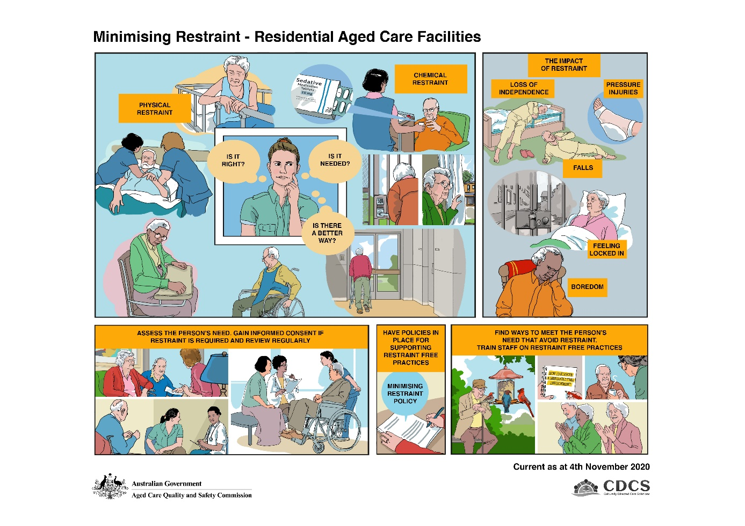
Restraint means any practice, device or action that interferes with a consumer’s ability to make a decision or restricts a consumer’s free movement. A restraint free environment is a basic human right for all consumers living and the use of restraints can infringe on a person’s right to freedom and dignity of choice. Restraints should only be used as a last resort, after all alternate strategies have been tried and following discussion with the person, their substitute decision maker and their doctor.
Frame 1: To minimise the use of restraint in the aged care setting it is important to understand and recognise what restraint is. To understand whether something is restraint, consider the following questions:
- Does this restrict the free movement of a person?
- Does this impede the free will of a person or their ability to make a decision (by affecting the way they think, feel, act, move)?
- Is this applied/administered to affect or change behaviour?
Below are some examples of different types of restraint. This list is not exhaustive:
Physical Restraint
- Holding onto a person to stop them taking a preferred path or holding a person down
- Bed rails or a lowered bed that makes it difficult for someone to easily get out
- Placing a table or something in front of a person that makes it difficult for them to get out of a chair
- Bed belt or lap sash restraint
- Locked doors and gates including those with codes or a keypad that a person has difficulty using
- A resident residing in a secure dementia unit.
There are also examples of ‘extreme’ restraints which are not condoned in aged care. These may include:
- Withholding access to personal items such as a mobile phone or TV programs
- Limiting access to food, cigarettes or drink.
Chemical Restraint
- Where medicine is used to control, sedate or restrict the movement or behaviour of a person instead of for the treatment of a diagnosed health condition.
Frame 2 (inset): Legislative requirements regarding the use of physical and chemical restraints are contained in the Quality of Care Principles 2014 (Principles). These Principles place explicit obligations on aged care providers to minimise chemical and physical restraints in residential care settings. The legislation makes it clear that restraints must only be used as a last resort. This means that staff must always consider if a practice is right, if it is actually needed and whether there is a better way to respond rather than using a restraint. Where restraint is used, informed consent must be obtained from the consumer or their substitute decision maker and consent should be recorded in writing.
The Principles specify that the residential aged care provider requires informed consent to use physical restraint.
With chemical restraint, if a medical practitioner or nurse practitioner prescribes medication, including restraint, they are the ones responsible for seeking informed consent.
While the provider is not responsible for obtaining consent for chemical restraint, the Commission expects that the provider has clinical governance arrangements in place to ensure that informed consent has been obtained and that medication being administered has been legally prescribed.
Note that a family member or legal representative does not have the legal power to require that a resident be restrained.
Frame 3: The use of restraint can harm the consumer. For example:
- the inappropriate use of medication - chemical restraint – can cause symptoms and may make behaviours worse. This can lead to a person becoming less independent, disorientated and falling out of bed.
- having a fixed bed rail in place - physical restraint - can cause injury if the consumer tries to climb over or around the rail and becomes trapped.
- Any sort of restraint that causes a consumer to remain confined to their bed may lead to pressure injuries, loss of mobility and function, boredom and/or depression.
- Some people who have previously been in care (people who have been institutionalised at some time in their life) can experience flashbacks and feelings of re-institutionalisation, panic and lack of control over their lives.
- People who are restrained may suffer a psychological injury or become physically agitated. This could lead to them being injured, hurting another person or damaging property.
Frame 4: To minimise the use of restraint, care staff must first know and understand the background, likes, dislikes, wishes and needs of each person. Consider and understand the needs of the person; getting to know the person well means you are more likely to anticipate their needs, be aware of triggers which may initiate behaviour responses and be aware of anything which might be calming.
Where any form of restraint is considered, even where the consumer or their family requests the use of restraint for the purpose of safety and security, it is important that this is discussed with the person, their substitute decision maker, their Doctor, and where appropriate their significant others. People often don’t understand the potential harms when restraints are used or applied. Alternatives to restraint must always be investigated with restraint only used as a last resort.
Insert information about consent
Any restraints approved for use must be lawful and the least restrictive form. Restraints should be used for a limited time and should be regularly reviewed. Use must be supported by detailed assessment, documentation, monitoring and reassessment.
Frame 5: All facilities must have policies in place that support a restraint free environment. Staff must be provided with training on identifying and understanding restraint and restraint-free practices.
Organisations that adopt person-centred policies and approaches are likely to follow an individualised care plan for each person they provide services for. A person-centred approach has been shown to reduce the need for restraint.
Frame 6: There are many actions, activities and responses that can be implemented to reduce the need for restraint. These can include seeing if the person is cold, bored, hungry or in pain, using diversional individual or group activities, meeting personal needs in a timely manner, engaging with the individual on a one to one basis and observing and responding to trigger events in promptly to avoid escalation of changed behaviours and improve quality of life.
For more information on minimising restraint in residential aged care and to access the Commission’s self-assessment tools visit: https://www.agedcarequality.gov.au/resources/minimising-use-restraints-resources

